Assignment 6: Multi-threaded Data Processing System

Prashanna Acharya
Advanced Programming Languages (MSCS-632-A01)
University of the Cumberlands
Dr. Jay Thom

Github Link: https://github.com/prashcodes10/MSCS-632-Assignment-6

Data Processing System: Java and Go Concurrency Comparison
Data Processing System Overview
This project implements a multi-threaded data processing system in both Java and Go. The purpose of the application is to simulate multiple worker threads processing tasks in parallel. In both implementations, tasks are stored in a shared queue, workers retrieve tasks, process them with a simulated delay, and then save the completed results to a shared output resource. The goal of the project is to demonstrate safe concurrency, proper synchronization, error handling, logging, and thread termination in two different programming languages.
Java Implementation
In the Java version, concurrency is handled using worker threads managed through an ExecutorService. A shared task queue is accessed by multiple workers, so synchronization is required to prevent race conditions. The queue operations, such as adding and retrieving tasks, are protected using synchronized methods or locking techniques. This ensures that only one thread can access or modify the shared queue at a time.
Each worker retrieves a task, processes it using a simulated delay with Thread.sleep(), and then writes the result to a shared results list or output file. Since file writing and shared list updates can also cause race conditions, these operations are also synchronized. The Java implementation uses try-catch blocks to handle exceptions such as InterruptedException and IOException. Logging messages are included to show when each thread starts, completes a task, finishes execution, or encounters an error.
Java’s concurrency model is based on threads and shared memory. Because multiple threads can access the same data, the programmer must carefully manage synchronization. This gives Java a lot of control, but it also requires more attention to avoid deadlocks, missed tasks, or duplicate processing.
Go Implementation
In the Go version, concurrency is handled using goroutines and channels. Instead of manually locking a shared queue, a channel is used as the task queue. Tasks are sent into the channel, and multiple goroutines receive tasks from the channel and process them. This approach reduces the need for explicit locking because channels are designed to safely pass data between goroutines.
Each worker goroutine processes a task with a simulated delay using time.Sleep(). After processing, the result is sent to a result channel or written to an output file. A sync.WaitGroup is used to make sure all worker goroutines finish before the program exits. Error handling in Go is done by checking returned error values after operations that can fail, such as file writing. The defer statement is used when needed to close files and release resources safely.
Go’s concurrency model focuses on communication instead of shared memory. Channels make it easier to coordinate workers and task flow without using many explicit locks. This makes the Go implementation shorter and often easier to understand for this type of worker-based system.
Comparison of Java and Go
The main difference between the Java and Go implementations is how concurrency is managed. Java uses traditional threads, executors, synchronized methods, and try-catch exception handling. This model gives more direct control over shared memory, but it also requires careful synchronization to avoid race conditions and deadlocks.
Go uses goroutines and channels, which provide a simpler way to pass tasks between workers. Instead of several workers directly accessing the same queue, tasks are sent through a channel. This makes the code cleaner and reduces the risk of shared-memory errors. However, Go still requires careful channel closing and proper use of WaitGroup to avoid goroutine leaks or deadlocks.
Error handling is also different between the two languages. Java uses exception handling with try-catch blocks, which separates normal logic from error-handling logic. Go does not use exceptions in the same way. Instead, errors are returned as values and checked immediately after function calls. This makes Go’s error handling very explicit.
Overall, both implementations meet the assignment requirements, but they demonstrate different programming styles. Java focuses on shared-memory concurrency with explicit synchronization, while Go focuses on lightweight goroutines and channel-based communication.
Conclusion
This project shows how a data processing system can be implemented using two different concurrency models. Java provides strong thread management tools through executors, locks, synchronization, and exception handling. Go provides a simpler and more lightweight concurrency model using goroutines, channels, WaitGroup, and explicit error checking. Both approaches can safely process tasks in parallel when synchronization and error handling are implemented correctly.
Screenshots
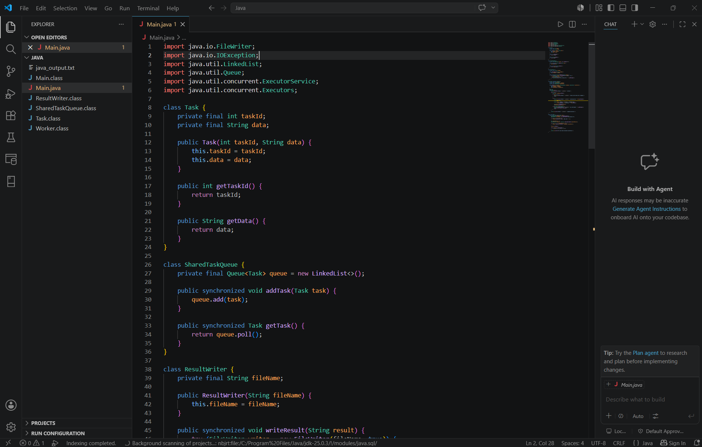
Fig: Java Code Screenshot

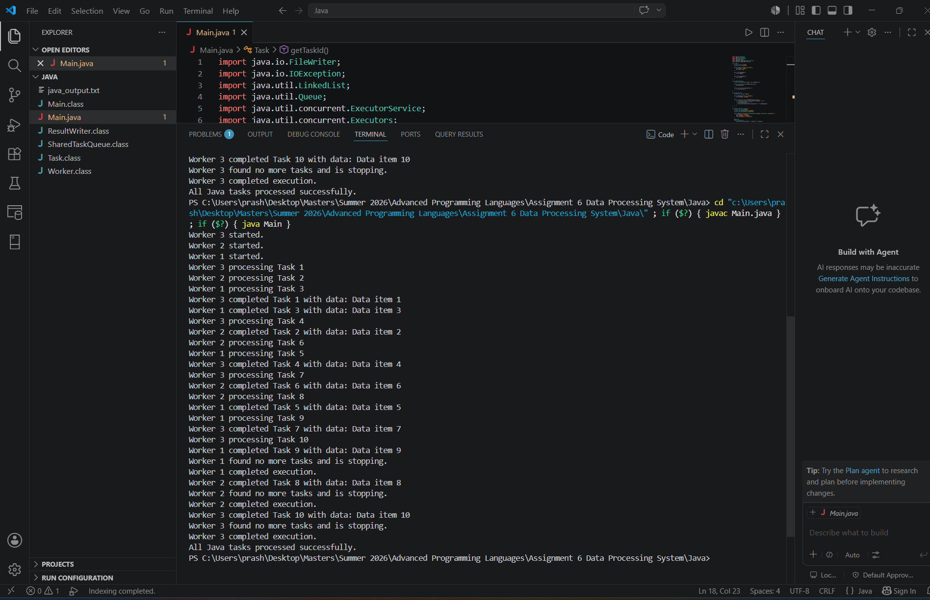
Fig 2: Java sample output
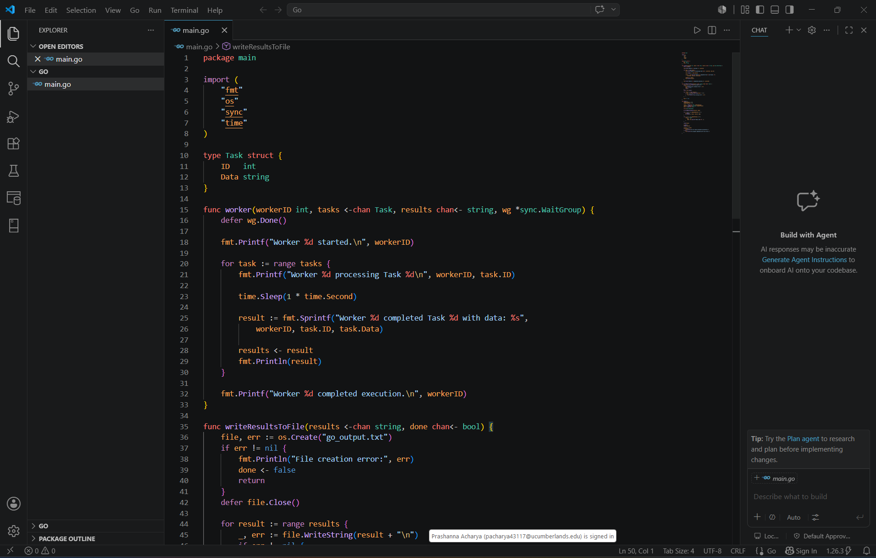
Fig 3: Go Code Screenshot

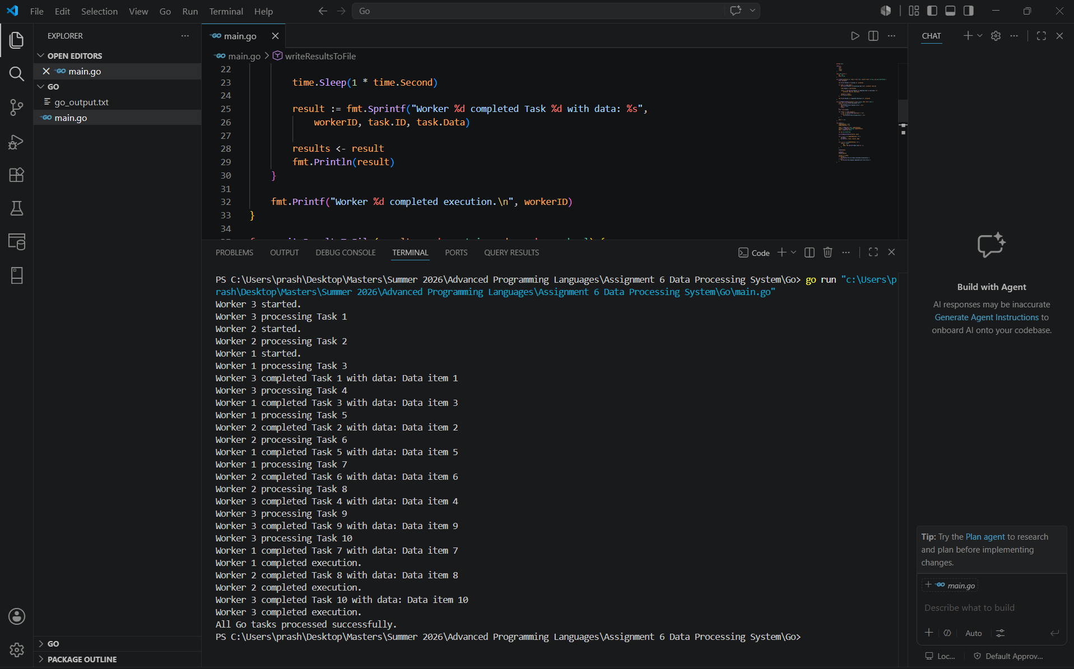
Fig 4: Go sample output

